ESP32 Digital Thermometer with OLED Display
Description:
This project builds a digital thermometer using an ESP32, a temperature sensor (e.g., DHT11/LM35), and an OLED display. The ESP32 reads the temperature and displays it in real-time. It demonstrates IoT concepts, sensor interfacing, and microcontroller display output, making it highly relevant for modern smart systems.
Block Diagram:
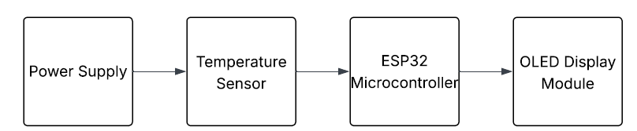
Pinout / Circuit Connection:
- DHT11/LM35 sensor OUT → GPIO 4
- OLED SDA → GPIO 21
- OLED SCL → GPIO 22
- VCC/GND → 3.3V and GND
Components Required:
- ESP32
- DHT11 or LM35 temperature sensor
- 0.96" OLED Display (I2C)
- Jumper wires
Working Principle:
The ESP32 reads analog/digital temperature values from the sensor. These values are processed and sent to the OLED display via I2C. The real-time temperature is updated continuously. With Wi-Fi capability, the ESP32 can also transmit the data online for IoT applications.
Operation (Step-by-Step):
- Connect sensor and OLED to ESP32.
- Upload thermometer code.
- View temperature on OLED display.
- (Optional) Extend by sending data to cloud.
Code:
// Using DHT11 sensor + SSD1306 OLED (I2C)
#include <Adafruit_SSD1306.h>
#include <Adafruit_GFX.h>
#include <DHT.h>
#include <Wire.h>

// OLED setup
#define SCREEN_WIDTH 128
#define SCREEN_HEIGHT 64
Adafruit_SSD1306 display(SCREEN_WIDTH, SCREEN_HEIGHT, &Wire, -1);

// DHT11 setup
#define DHTPIN 4
#define DHTTYPE DHT11
DHT dht(DHTPIN, DHTTYPE);

void setup() {
Serial.begin(115200);

// Initialize OLED
if (!display.begin(SSD1306_SWITCHCAPVCC, 0x3C)) {
Serial.println("OLED not found");
for (;;);
}
display.clearDisplay();
display.setTextSize(1);
display.setTextColor(WHITE);

// Initialize DHT sensor
dht.begin();
}

void loop() {
float temp = dht.readTemperature(); // Read Celsius
float hum = dht.readHumidity(); // Read Humidity

// Check if sensor works
if (isnan(temp) || isnan(hum)) {
Serial.println("Sensor error!");
return;
}

// Print to Serial
Serial.print("Temperature: ");
Serial.print(temp);
Serial.print(" °C Humidity: ");
Serial.print(hum);
Serial.println(" %");

// Print to OLED
display.clearDisplay();
display.setCursor(0, 10);
display.setTextSize(2);
display.print("Temp: ");
display.print(temp);
display.print(" C");

display.setCursor(0, 40);
display.setTextSize(2);
display.print("Hum: ");
display.print(hum);
display.print(" %");

display.display();

delay(2000); // Update every 2 seconds
}
Conclusion:
This project combines sensor interfacing, microcontroller programming, and display control, showcasing IoT-based monitoring systems. It’s a practical project with real-world applications such as weather stations and home automation.
References:
[1] R. Santos, “ESP32 OLED Display with Arduino IDE,” Random Nerd Tutorials, 2020. [Online]. Available: https://randomnerdtutorials.com/esp32-ssd1306-oled-display-arduino-ide/. [Accessed: Sep. 13, 2025].
[2] Espressif Systems, “ESP32 Technical Reference Manual,” 2019. [Online]. Available: https://www.espressif.com/sites/default/files/documentation/esp32_technical_reference_manual_en.pdf. [Accessed: Sep. 13, 2025].

